Immigration to the U.S.

Immigration in the United States significantly influenced the demographic and the culture of the country. Since the founding of the United States a large numbers of migrants settled down because of religious, political or economic motives or were forced to be slaves.

The first immigrants came from the United Kingdom and the Netherlands. The immigration climax was reached between 1892 and 1924. Today, there are more legal immigrants living in the United States than in any other country in the world.

Inflow of New Legal Pe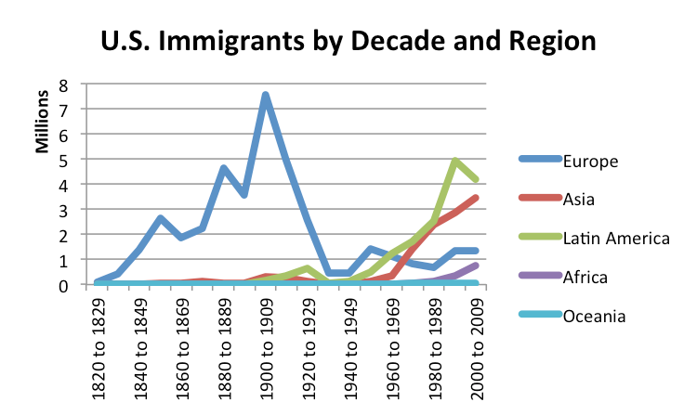rmanent Residents by continent in 2013:

Asia (40.43%)
Americas (40.04%)
Africa (9.92%)
Europe (8.74%)
Australia and Oceania (0.53%)
Unknown (0.33%)

(picture source: http://3.bp.blogspot.com/-xjy1mFmqTCE/UjMh9XP6wRI/AAAAAAAAAYM/BHQacaKdslk/s1600/immigrant+history+091213.png)

Immigration in the North American colonies

After the European discovery of America 1492, the settlement of the North American continent by europeans happened because of three main directions:

Spaniards settled first in Central America and moved then (from about 1528) coming from the south of the Rio Grande in the territory of the present-day California, which name (San Francisco, Los Angeles) are recognizable Spanish origin. After the Mexican-American War (1846-1848) half of the former Mexican territory was divided among several US states.
French populated (from about 1605) the continent from the north-east; Quebec is a French founding and the present-day lying in the United States city of Detroit (French, for strait) or the State of Illinois (French. adjectivation of Illini). From the mid-west of the Mississippi River French settlers then moved south along, which state name like Louisiana (Louisiane) or city names such as New Orleans (Nouvelle Orléans) testify.
English settlers first landed in the state, that is now called Jamestown (VA) (1607) and 1620 with the Mayflower in Massachusetts.
Other major reasons for immigration to the US were:

1628-1640: Approximately 20,000 English Puritans settled in New England.
1629-1640: 8000 Dutch settled in the United States.
1645-1670: 45,000 English royalists immigrated in the middle colonies and Virginia.
1675-1715: Quakers from England settled in Pennsylvania, New Jersey and Delaware.
1710-1775: 250,000 Scottish Irish from Ulster settled in western Pennsylvania and the Western Frontier. Immigration of the Pennsylvania Dutch, mostly German Protestants from the Palatinate.

Immigration policy since 1924

In 1921 a quota was initiated for the immigration to the US by the government for the first time (Emergency Quota Act). Three years later came the Immigration Act of 1924th.
The quotas adopted in both laws should curb immigration from southern and eastern Europe in favor of immigration from Northern and Western Europe and secure the "white" character of the population in general. The number of new immigrants per country was limited to 2% of the proportion of the population in 1890.

By lifting the racial quota system in 1924, the composition of the immigrant changed dramatically. In 1970 62% of foreign-born US residents Europeans, this proportion dropped to 2000 to 15%. The number of immigrants increased considerably. It ranged from 1951-1960 2.5 million, from 1971 to 1980 and 4.5 million in the 1990s, more than 10 million.

Becoming American: Understanding legal and illegal immigration

The United States is one hot destination. Whether the lure is Hollywood, the Statue of Liberty or the world's highest standard of living, people pour over American borders every day, searching for a better life. To do either, every one of these people is legally required to have a visa, issued by the United States Department of State. If someone comes to the United States without a visa, or stays after his or her visa is expired, that person is breaking the law.

Visas issued

Two types of visas are issued by the U.S. government - immigrant and non-immigrant. Those holding immigrant visas usually go on to become resident aliens or legal permanent residents, and obtain their green cards. Most immigrants eventually become citizens of the United States. Non-immigrant visas are issued to people who return to their homeland when their trip or schooling is completed, such as tourists or students.

What is an illegal alien?

The Immigration and Nationality Act of 1952 defines an alien as a person who is not a citizen or national of the United States. In other words, an alien is anyone born in a country other than the United States to parents who are not United States citizens.

An illegal alien is someone who is living in the United States illegally; either without the correct legal documentation or by violating the terms of documentation, such as overstaying the time period specified on a tourist or student visa. Illegal aliens have no legal status in the United States. Among other things, illegal immigrants cannot vote, receive social services from federally funded programs, social security benefits, or hold United States passports.

Illegal aliens are subject to detainment and deportation at any time, as are legal aliens if they commit and are convicted of a crime. In many cases however, unless an illegal alien has committed a crime and been convicted, most are not detained or removed from the U.S. simply because they cannot be identified as illegal aliens.

Becoming a naturalized citizen
The process of becoming a United States citizen with full citizenship rights is called naturalization. Overseen by the Bureau of Citizenship and Immigration Service (BCIS), there are several ways for aliens to become naturalized. The most common way, used by individuals who hold an immigrant visa, is to obtain legal permanent resident status by residing in the country for a period of five years. During this time, a legal alien may not spend more than six months at once overseas. He or she must be physically present in the country for at least six months of the year for a total minimum of two and a half years.

It is possible to become a permanent legal resident and later, a naturalized citizen through marriage to a United States citizen. In this case, the naturalization period is shortened from five years to three years, provided the couple has been married for at least three years and the spouse is still a citizen of the United States.

Other factors that affect naturalization and eligibility for citizenship include being at least 18 years old, possessing good moral character and basic reading and writing skills. Potential citizens are required to understand United States government and history, although there are some age-related exceptions to the latter two.

After the application and interview process is completed, the BCIS will grant or deny citizenship to the individual who has applied. If the BCIS needs more information before a decision can be made, it will continue the case. Individuals who have been denied citizenship may appeal.

This country was built on the strength of its immigrant population. While the face of the American immigrant has changed and will change over the years, one thing remains the same: you can enter just as long as you have the correct paperwork and can follow the State Department's rules.

source: https://www.legalzoom.com/articles/becoming-american-understanding-legal-and-illegal-immigration

