Eleonora Meyer
English
Ethnic groups in the US and
Immigration to the US
Legal & Illegal

Ethnic groups in the US:
- White is the most common race in the US; It refers to people from Europe or the Middle East (Germany , England ,Italy..)
- Black or African-American refers to people from most parts of Africa (most of them came to the US as slaves)
- Asian refers to people from countries in Asia(China,Japan,Philippines...)
- Native American or American Indian refers to people who are part of Native American groups that lived in the US for thousand of years
- Some other races such as Hispanic Americans: Mexican (Hispanic can be also any other race)
- The most common is German-American :At least 42.8 million Americans say that they are this
- Many people came to the US from Germany in the 19th and early 20th century
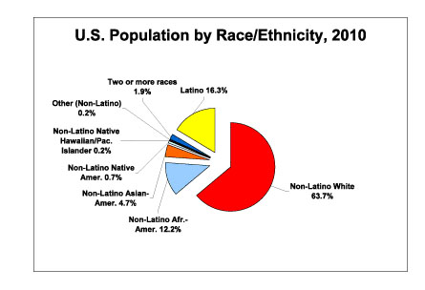
Immigration to the US:
- Early immigration (1700s – 1850)
- Second wave (1850 – 1970)
- Recent immigration (1970 – present)
- US Immigration Laws were passed during each of these periods and the laws reflected the government policy of the period
- In the late 1800's Laws were passed to regulate and restrict immigration to the US
- The Ellis Island center in New York opened on January 1, 1892 -> immigrants from Europe entered the United States
- The Angel Island Station in San Francisco Bay opened on January 21, 1910 ->immigrants from China, Japan and Asia, entered the United States
- Between 1817 and 1930 , 30 million immigrants came to the US->fleeing from political and religious intolerance
- They were seeking financial opportunities
- Absorbed about 60% of worlds immigrants-> government officials and business leaders recognized they could file the need of cheap labor and encouraged flow of workers
- 1875 the borders were closed because they did not want undesirables and Chinese workers
- 2010 census: more than 11 million people lived in the US illegal

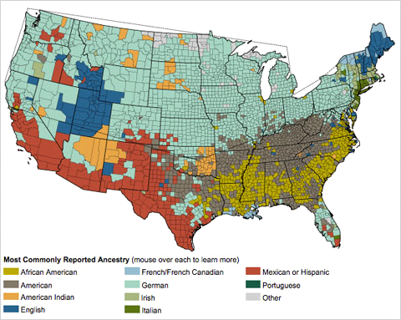

Legal&Illegal:

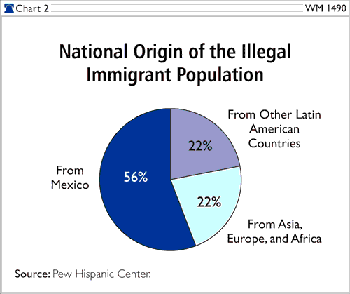
- There are 2 types of visas:immigrant and non-immigrant
- Immigrant:legal permanent residents and obtain green cards → eventually become a citizen of the US
- Non-immigrant:They have to return to their homeland → if not they can be deportated anytime or they can not be identified as illegal aliens so they can not be removed
- The majority of the illegal immigrants are from Mexico
- In a 2011 news story,Los Angeles Times reported, "The annual REPORT”found out that illegal immigrants in the US in 2010 were parents of 5.5 million children, 4.5 million of whom were born in the US and are citizens now

